# Abstract

Online Shopping is developing at a much faster rate today than it was five years ago. Despite online sales accounting for just three percent of all retail in 2017, the digital commerce sphere was estimated to reach 330 million buyers online by 2020. Out of a 100 thousand pin codes in the country, online deliveries were available for up to 20 thousand, indicating a drastic development. With such drastic development, technological advancements in the experience of the customers are not just a utility, but a necessity. Customer Satisfaction is the key driver to enterprise’s success. The experience of the customer during their time at the shopping website/application is the most crucial to driving the customer to purchase the product.

Augmented Reality (AR) is a new and upcoming technology that is proposed to take over the current internet experience in the coming years. With the help of this technology, a user gains the ability to experience the product in a virtual manner. This helps the user in making informed decisions and improves the overall shopping experience.

AR Shopping Experience: It’s an application that helps improve the current online shopping experience of an online shopper by introducing Augmented Reality. It helps the customers to visualize the product and see how the product fits the requirement of the customer.

Contents

Acknowledgement 4

Abstract 5

Introduction 7

Project Scope 8

Brief Architecture 9

Augmented Reality 11

3D Visualization 11

Interactive Objects 11

Smart Cards 12

Product Function for users: 12

Tracking Design 13

Non-Functional Requirements 14

**Performance** 14

Portability and compatibility 14

Reliability, Availability, Maintainability 14

Usability 15

Trade off Analysis 16

UML 17

Entity Relationship Diagram 17

Sequence Diagram 18

Data Flow Diagram 19

Code Flow Chart 20

Conclusion 21

Bibliography / References 22

# Introduction

**Document Purpose**

The purpose of this document is to describe the high-level design document for the AR shopping project. This document will act as an outline for implementation and discuss the design considerations.

**Project Overview**

The document is structured to initially describe the solution at a high level and progressively provide more detail to the point where all the solution requirements of each system have been detailed. The first sections provide the context of the solution, briefly describing the business reason and then how the solution fits with software vendor’s application. The following sections then detail how the solution will work and be structured, how the functional requirements will be met, and what the requirements are on each individual component of the solution.

**Purpose**

The purpose of this project is to create a functional mobile application for people to be able to visualize the product before they buy any product from online websites. Augmented reality (AR) has opened a world of shopping experience possibilities. With this project I am trying to improve the shopping experience of the customers so that they can try the product before they buy it.

Currently, users are purchasing the product by just having a look at an image. With the proposed solution however, we will be able to provide a better experience for customers so that they can visualize the product much before they make the decision of purchasing it. It will not only help the company to save cost on unwanted logistics but will also retain the expectations of the customers as they have already virtually tried out the product.

# Project Scope

|  |  |  |  |
| --- | --- | --- | --- |
| Serial Number of Task | **Tasks or subtasks to be done** (be precise and specific) | Planned duration in weeks | Specific Deliverable in terms of the project |
| 1  2  3  4  5 | As a user, I must be able to visualize the Watch on my hands  As a user, I must be able to swap multiple watches (Smooth User Interface, Occlusion shader and swap functionality)  As a user, I must be able to place objects like refrigerator and washing machine in a 3d space and visualize the product before purchasing it.  As a user, I would receive a card that would display a tutorial for the product when the phone camera pans over to the card.  As a user, I must be able to visualize glasses and sunglasses on my face with the option of swapping and changing colors. | 2 weeks  2 weeks  4 weeks  4 weeks  4 weeks | AR App with a basic functionality.  App enhanced with more options to switch.  Place 3d objects,  360-degree Rotation  A shopping card to get more information about the product.  Shopping for glasses and sunglasses. |

Table 1: the business requirements for the project

**Technologies used**

The list below will highlight all software and technologies used in order to create the project:

1. **Blender 3d**: used for 3d Model of Watch, also used for the process of UV – Unwrap, Fixing Normal Map and Materials.
2. **Vuforia Engine**: used for tracking real world Image Target.
3. **Microsoft visual Studio**: Integrated Development Environment used to write and debug code.
4. **Unity Engine**: Used for creating the entire application. All the rendering logic and user input handling was done using unity engine

# Brief Architecture

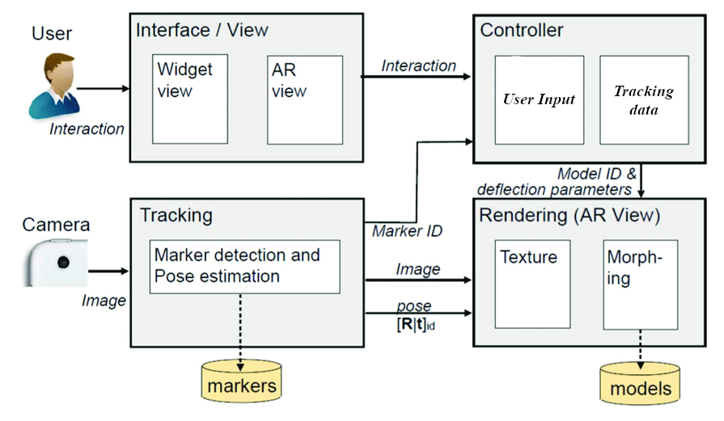

Image 1: Architecture Diagram

The application takes into consideration the dynamically changing products in the marketplace and allows the admin to take control of the process of regularly updating the displayed products with a simple portal. The Admin uploads a new product and its necessary details in an Admin Portal which is a UI enriched User Level Layer to facilitate easy upload of products. The Admin Portal calls in a Middle layer PHP Service that sends the necessary data to the Inner Layer Data Store. Then, the admin is required to initiate the upload to the Mobile Handheld Device whenever the Admin feels that a buffer size of data items has been uploaded to the Data Store and it should be updated in the Mobile Handheld Device. The initiation is done in the Unity Project Layer which is directly connected to a Unity Script. The Unity Script also connects to a Middle Layer PHP Service to get the required data from the Data Store and makes the necessary changes in the Mobile Handheld Device which is reflected dynamically as soon as the service is initiated.

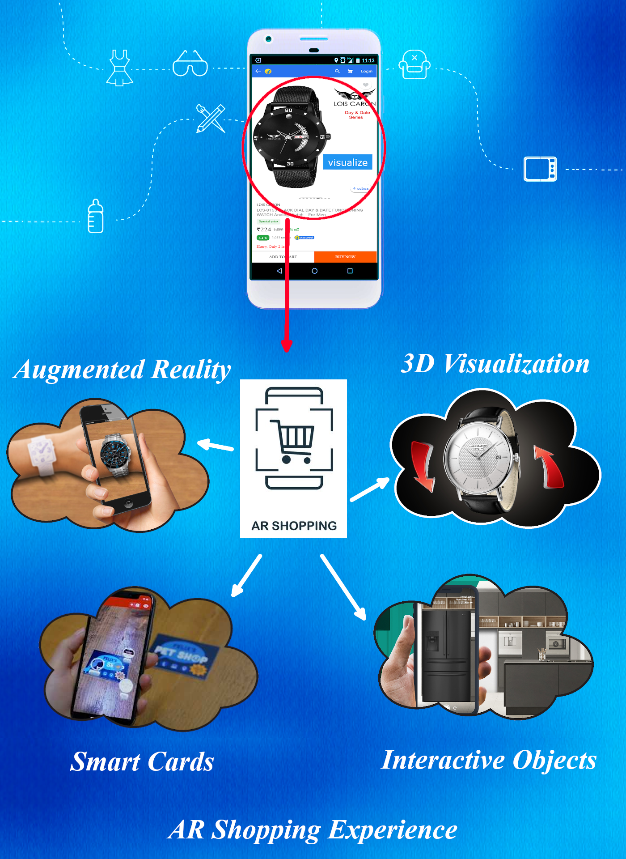

Image 2: AR Shopping Experience

## Augmented Reality

Augmented Reality (AR) is an interactive experience of the real-world environment where the objects that reside in the real world are enhanced by the computer-generated perceptual information, sometimes across multiple sensory modalities, including visual, auditory, haptic, somatosensory and olfactory. AR can be defined as a system that fulfills three basic features: a combination of real and virtual worlds, real-time interaction and accurate 3D registration of virtual and real objects.

However, in this project we limit our application of AR to the visual senses and mapping real world objects onto a virtual space envisioned through a mobile application. As the name of the project suggests, Augmented Reality is used to provide a wholesome shopping experience to the user. With the help of the application, the user will be able to have a virtual experience of the product that they are about to purchase. This will help them make better decisions and purchase products specific to their requirements.

## 3D Visualization

The term 3D visualization is used synonymously with 3D graphics, 3D rendering, computer generated imagery (CGI), and other terms. They all basically refer to the process by which graphical content is created using 3D software. It’s a technology that has become mainstream over the last few decades and has evolved into one of the most viable options for producing high-quality digital content.

In the context of this project, the products which are on display for sale can also be visualized apart from experiencing the product in an augmented reality environment. The Visualization feature allows observing the product as a 3D model and rotating and looking at it from all angles to get a better idea of the actual product. All these features help in having an enhanced shopping experience with the help of Augmented Reality.

## Interactive Objects

Interactive Objects are special objects that can respond to the user's input in pre-specified manners. They enhance the interaction and communication between the application and the user. In the context of our application, we have implemented a unique feature that helps the user have an all-round wholesome experience while exploring the products. For instance, the Refrigerator opens and shows the inner space of the refrigerator when the user comes close enough. When the user reaches a certain distance from the object, the objects interact with the user in some way. This feature can also be expanded to multiple other products and be activated by different types of gestures. Interactivity of objects enhance the user experience and makes users stay on the application for longer periods increasing the chance of purchase of the product.

## Smart Cards

Smart Cards, in terms of the Augmented Reality Experience, are cards that allow portrayal of information through videos or different 3D models that help the user understand the product better. It is similar to scanning a card to experience the product but instead a promotional or informative video starts playing when the card is scanned. This feature allows the user to easily access realistic product tutorials and explanations that help them set-up the products for the first time. These videos can also be used to fix problems by pointing out to the user the exact issue. It would allow companies to interact with users more effectively and allow the users to fix their own issues before raising complaints.

## Product Function for users:

1. Try Wearable product like watch.
2. Swap different kinds of watch and try multiple watches on a click of button.
3. Place refrigerator in the 3d space.
4. Rotate and scale objects according to the requirement.
5. Use E Marketing cards to know more about the product.

# Tracking Design

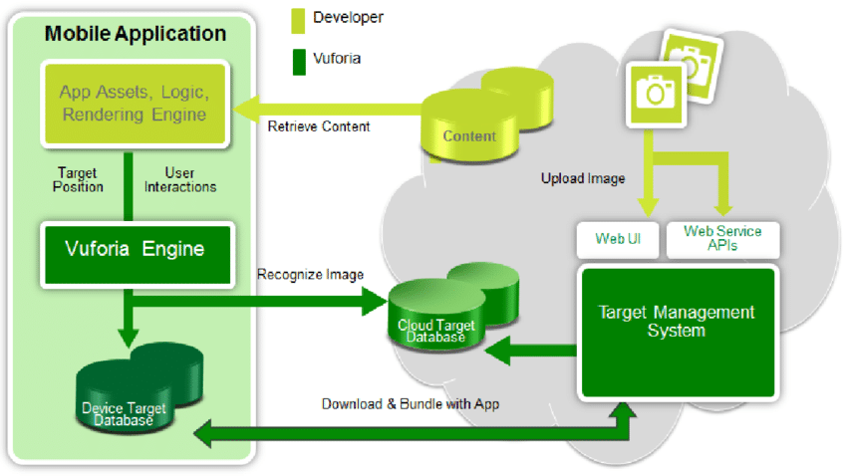

Image 3: Vuforia Tracking Diagram

The image is uploaded to the Web UI or a Web Service API which then takes the images and stores it in the form of a Database. The Database is then fed into the Target Management System. The processed database is then downloaded and bundles with the App to form a package and stored inside the Device Target Database. The App Assets, Logic that defines the functioning of the application and the Rendering Engine are then retrieved from the Online Cloud Storage System into The Mobile Application. The Downloaded content is then fed into the Vuforia Engine in accordance to the User Interaction and the Target Position. The Vuforia Engine recognizes the image and sends it to the Cloud Target Platform where the data from the Target Management System is already present and the required result is generated.

The image is first uploaded to the Vuforia Web Database, and then the image is processed to generate features about the image which helps in recognizing the characteristics of the image and the result to be produced. The Database is then converted into a local Database and encapsulated into a unity package containing required characteristics and features of the image. This process is done by the Vuforia Engine Web Portal. An image tracker is used to

# Non-Functional Requirements

The Non-Functional Requirements include:

**Performance**

**Performance** defines how fast a software system, or its particular piece responds to certain users’ actions under certain workload. In most cases, this metric explains how much a user must wait before the target operation happens (the page renders, a transaction is processed, etc.) given the overall number of users now. But it’s not always like that. Performance requirements may describe background processes invisible to users, e.g. backup. But let’s focus on user-centric performance. My Application performed well under the specific criteria defined above.

## Portability and compatibility

**Portability** defines how a system or its element can be launched on one environment or another. It usually includes hardware, software, or other usage platform specification. Put simply, it establishes how well actions performed via one platform are run on another. Also, it prescribes how well system elements may be accessed and may interact from two different environments. My Application is quite versatile and supports all smart devices enables with a camera. Portability also has an additional aspect called compatibility.

**Compatibility** defines how a system can co-exist with another system in the same environment. For instance, software installed on an operating system must be compatible with its firewall or antivirus protection. My Application is compatible with most Android devices that support AR Core and its supplementary applications.

Portability and compatibility are established in terms of operating systems, hardware devices, browsers, software systems, and their versions. For now, a cross-platform, cross-browsing, and mobile-responsive solution is a common standard for web applications.

## Reliability, Availability, Maintainability

While these three types of requirements are usually documented separately, we aggregate them in one section, since they approach the same sort of a problem from different angles. Another thing to keep in mind with these requirements is that they are extremely hard to express in calculative terms. And, frankly, many system providers don’t document them at all. Let’s see.

**Reliability**This quality attribute specifies how likely the system or its element would run without a failure for a given period under predefined conditions. Traditionally, it’s expressed as a probability percentage. For instance, if the system has 85 percent reliability for a month, this means that during this month, under normal usage conditions, there’s an 85 percent chance that the system won’t experience critical failure.

As you may have guessed, it’s tricky to define critical failure, time, and normal usage conditions. Another, somewhat simpler approach to that metric is to count the number of critical bugs found in production for some period or calculate a mean time to failure.

**Maintainability** Maintainability defines the time required for a solution or its component to be fixed, changed to increase performance or other qualities, or adapted to a changing environment. Like reliability, it can be expressed as a probability of repair during some time. For example, if you have 75 percent maintainability for 24 hours, this means that there’s a 75 percent chance the component can be fixed in 24 hours.

**Availability** And finally, availability describes how likely the system is accessible for a user at a given point in time. While it can be expressed as a probability percentage, you may also define it as a percentage of time the system is accessible for operation during some time period. For instance, the system may be available 98 percent of the time during a month. Availability is perhaps the most business-critical requirement, but to define it, you also must have estimations for reliability and maintainability.

## Usability

Usability is yet another classical nonfunctional requirement that addresses a simple question: How hard is it to use the product? Defining these requirements isn’t as easy as it seems. There are many types of usability criteria. One of the most popular one ones by Nielsen Norman Group suggests evaluating usability with two dimensions:

**Learnability**How fast is it for users to complete the main actions once they see the interface? My Application is designed in a certain way that allows the user to understand its functionality easily.

**Efficiency**How quickly users can reach their goals? The main purpose of using my application is to take advantage of an online shopping experience and hence the application is centered upon the basic idea of attaining the experience right away.

# Trade off Analysis

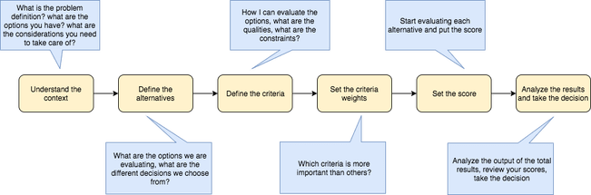

Image 4: Steps involved in decision making

The main problem faced while building this application was the usage of certain inbuilt applications which wouldn’t be compatible with each other most of the times. There was a tradeoff between using the Unity AR Core and Vuforia Engine. The AR Core library was quite vast and could have allowed me to optimize a lot of algorithms used in the application but since the AR Core was not compatible with many devices hence, I chose to use Vuforia Engine and its image tracking functionalities.

**Why have you chosen this Design?**

The AR Core library was quite vast and could have allowed me to optimize a lot of algorithms used in the application but since the AR Core was not compatible with many devices hence, I chose to use Vuforia Engine and its image tracking functionalities.

# UML

The Unified Modeling Language (UML) is a general-purpose, developmental, modeling language in the field of software engineering that is intended to provide a standard way to visualize the design of a system

## Entity Relationship Diagram

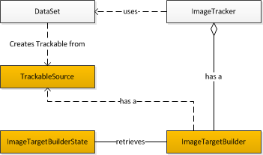

Image 5.1: ER Diagram

The image target builder retrieves the Image target builder state and has a trackable source. The Dataset creates a trackable form for the trackable source. The image target builder also has an image tracker that uses the dataset.

## Sequence Diagram

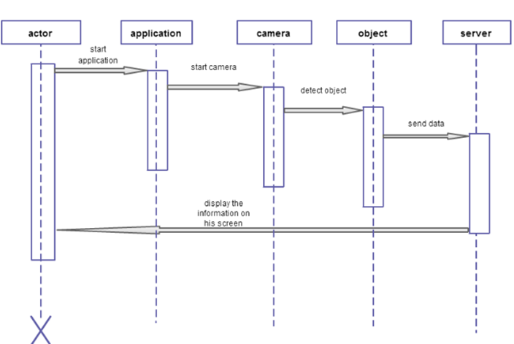Image 5.2: Sequence Diagram

The user starts the application and then the camera starts detecting objects. As soon as the object is detected, the data is sent to the server which processes the data and displays the corresponding information on the user’s screen.

## Data Flow Diagram

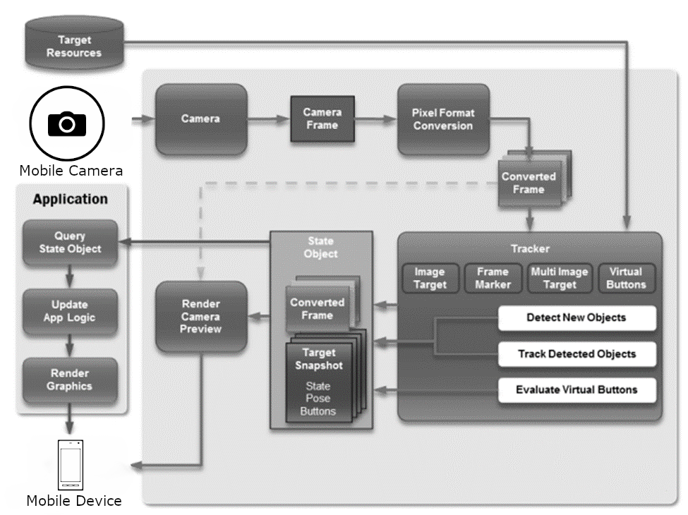

Image 5.3 Data Flow Diagram

## Code Flow Chart

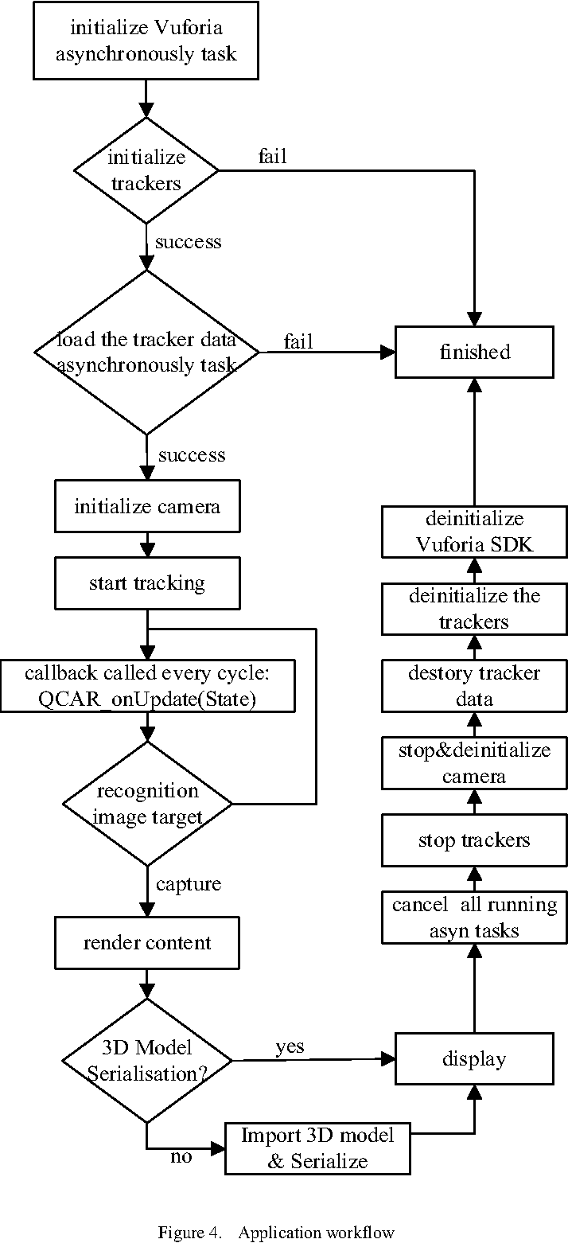

Image 5.4 Code Flow Chart

# **Conclusion**

The project implementations have shown that the experience of a user can be improved drastically by implementing newer technologies like Augmented Reality. This will increase the scope for businesses as the customer tends to stay on the website/application for longer and hence improve the chances of purchase. This will give the required boost to Online E-Commerce Websites because it is clear that this industry is in its early stages and there is a lot of scope for the improvement of the Online Market Scheme.

The new and upcoming generation has already been shown to prefer Online E-Commerce over Offline Markets and this indicates that there might be a boom in the E-Commerce industry making way for technologies like Augmented Reality to be a necessity and not just a utility.

# Bibliography / References

[1] <https://programminghistorian.org/en/lessons/creating-mobile-augmented-reality-experiences-in-unity>

[2] <https://jasoren.com/making-an-ar-app-with-vuforia-and-unity3d/>

[3] <https://blogs.unity3d.com/2018/01/15/vuforia-in-unity-build-cross-platform-ar-apps/>

[4]<https://docs.unity3d.com/2018.2/Documentation/Manual/vuforia_get_started_project_setup.html>

[5]<https://docs.unity3d.com/2018.2/Documentation/Manual/vuforia_get_started_displaying_3d_content.html>